**Lab Report: 02**

**Title: Scan conversion**

*Course title: Computer Graphics Laboratory*

*Course code: CSE-304*

*3rd Year 1st Semester Examination 2022*

**Date of Submission**: 04/06/2023



**Submitted to-**

*Dr. Mohammad Shorif Uddin*

*Professor*

*Department of Computer Science and Engineering*

*Jahangirnagar University*

*&*

*Dr. Morium Akter*

*Associate Professor*

*Department of Computer Science and Engineering*

*Jahangirnagar University*

*Savar, Dhaka-1342*

| Class Roll | Exam Roll | Name |
| --- | --- | --- |
| 355 |  | Syeda Faria Sithi |

**Experiment no: 01**

**Experiment Name: Scan conversion of circle using midpoint circle algorithm**

Source Code:

#include <iostream>

#include <graphics.h>

using namespace std;

void drawCircle( int centerX, int centerY, int radius)

{

int x = 0;

int y = radius;

int d = 1 - radius;

while (y > x)

{

putpixel(centerX + x, centerY + y, WHITE);

putpixel(centerX + y, centerY + x, WHITE);

putpixel(centerX - x, centerY + y, WHITE);

putpixel(centerX - y, centerY + x, WHITE);

putpixel(centerX + x, centerY - y, WHITE);

putpixel(centerX + y, centerY - x, WHITE);

putpixel(centerX - x, centerY - y, WHITE);

putpixel(centerX - y, centerY - x, WHITE);

if (d < 0)

{

d += 2 * x + 3;

} else

{

d += 2 * (x - y) + 5;

y--;

}

x++;

}

}

int main()

{

int x, y, r;

cout << "\nEnter the x-coordinate of the center: ";

cin >> x;

cout << "Enter the y-coordinate of the center: ";

cin >> y;

cout << "\nEnter the Radius of the circle: ";

cin >> r;

int gd = DETECT, gm;

initgraph(&gd, &gm, "");

drawCircle(x,y,r);

delay(5000);

getch();

closegraph();

return 0;

}

**Output:**

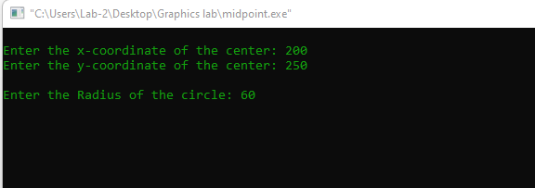

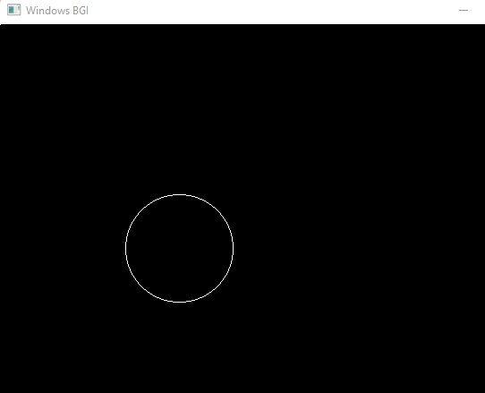

**Experiment no: 02**

**Experiment Name: Scan conversion of a Ellipse**

Source Code:

#include <iostream>

#include <graphics.h>

#include<bits/stdc++.h>

using namespace std;

void drawEllipse(int xc, int yc, int a, int b)

{

int x = 0;

int y = b;

int a_sqr = a * a;

int b_sqr = b * b;

int d = b_sqr + (a_sqr * (0.25 - b));

while ((2 * b_sqr * x) <= (2 * a_sqr * y))

{

putpixel(xc + x, yc + y, WHITE);

putpixel(xc - x, yc + y, WHITE);

putpixel(xc + x, yc - y, WHITE);

putpixel(xc - x, yc - y, WHITE);

if (d < 0)

{

x++;

d += (b_sqr * (2 * x + 3));

}

else

{

x++;

y--;

d += ((b_sqr * (2 * x + 3)) + (a_sqr * (2 - 2 * y)));

}

}

d = (b_sqr * (x + 0.5) * (x + 0.5)) + (a_sqr * (y - 1) * (y - 1)) - (a_sqr * b_sqr);

while (y >= 0)

{

putpixel(xc + x, yc + y, WHITE);

putpixel(xc - x, yc + y, WHITE);

putpixel(xc + x, yc - y, WHITE);

putpixel(xc - x, yc - y, WHITE);

if (d > 0)

{

y--;

d += (a_sqr * (3 - 2 * y));

}

else

{

y--;

x++;

d += ((b_sqr * (2 * x + 2)) + (a_sqr * (3 - 2 * y)));

}

}

}

int main()

{

int xc, yc, a, b;

printf("*** Ellipse Generating Algorithm ***\n\n");

printf("Enter the value of Xc: ");

scanf("%d", &xc);

printf("Enter the value of Yc: ");

scanf("%d", &yc);

printf("Enter X axis length: ");

scanf("%d", &a);

printf("Enter Y axis length: ");

scanf("%d", &b);

drawEllipse(xc, yc, a, b);

int gd = DETECT, gm;

initgraph(&gd, &gm, "");

drawEllipse(xc, yc, a, b);

delay(5000);

getch();

closegraph();

return 0;

}

**Output:**

